P&O EAGLE
Resonant Wireless Power Transfer (WPT)
Hamada Almasalma, Ruth V. Sabariego
August 4, 2017

Acronyms and symbols

UAV | Unmanned Aerial Vehicle
WPT | Wireless Power Transfer
EMF | Electromotive force
LC circuit | Circuit consisting of an inductor and a capacitor
L | Inductor
C | Capacitor
R | Resistor
r | Radius
W | Watt
cm | centimeter
PCB | Printed circuit board
DC | Direct current
AC | Alternating current
V | Voltage
ZYBO | Main microcontroller of the drone
MOSFET | Metal–oxide–semiconductor field-effect transistor
$$d$$ | distance
$$ω$$ | Angular frequency
$$S_{21}$$ | Transmission coefficient
$$η$$ | Efficiency

1 Objective
The objective of this module is to design and build an efficient resonant wireless power transfer system to transfer sufficient power from the battery of the drone to a load placed on the ground.

2 Introduction

Unmanned Aerial Vehicles (UAVs) or drones capture the imagination of the general public and companies alike. Not only are drones a fun hobby, offering e.g. the opportunity to take pictures and videos from impossible angles, but they become a useful tool in multiple civil/commercial applications [1, 2], e.g. a drone can help charging wireless sensor networks.

Wireless sensor networks are widely used, from border security to monitoring waterway pollution. Supplying energy for long term deployment is a crucial challenge in wireless sensor networks, as batteries are the primary energy source. Current wireless sensor networks deployed for long periods require either additional infrastructure (e.g. solar panels) or periodic maintenance. The use of small drones equipped with resonant wireless power transfer for charging the sensor nodes and prolonging the sensor network lifetime is an attractive alternative. See e.g. Fig. 1 that represents a drone charging wireless sensor nodes, which monitor the structural health status of highway bridges.
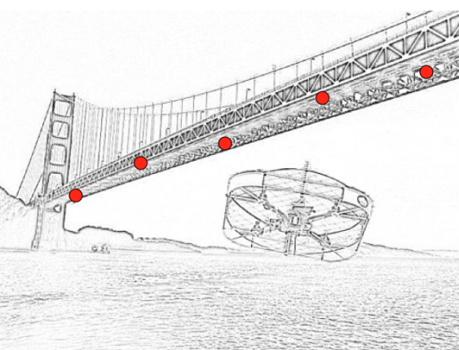
Figure 1: A drone helps charging bridge sensor nodes used for monitoring structural health.

3 Operation principle of wireless power transfer

It is already known that the true inventor of the radio was Nikola Tesla, therefore, makes sense to think this scientist inferred, if it was possible to transfer information using an electromagnetic field, it would be also possible to transfer power using the same transmission medium or vice versa. Thus, in the early 19-nth century this prominent inventor and scientist performed experiments (Tesla (1914)) regarding the wireless energy transfer achieving astonishing results by his age. It has been said that Tesla’s experiments achieved to light lamps several kilometers away. Nevertheless, due to the dangerous nature of the experiments, low efficiency on power transfer, and mainly by the depletion of financial resources, Tesla abandoned experimentation, leaving his legacy in the form of a patent that was never commercially exploited [3].

Wireless Power Transfer (WPT) makes it possible to supply power through an air gap, to provide power from an AC source to compatible batteries or devices without physical connectors [4].

Ampere’s circuital law and Faraday’s law of induction are the two key principles behind the operation of WPT. Ampere’s circuital law states that a magnetic field is produced around a conductor carrying electric current with a strength proportional to the current. On the other hand, Faraday’s law of induction states that an alternating magnetic field can induce an electromotive force (EMF) in a conductor that is proportional to the magnetic field’s strength and its rate of change.

Fig. 2 illustrates how these two laws can be applied together to transfer power wirelessly. An alternating current circulates through a coil, referred to as the primary or transmitting coil, and generates an alternating magnetic field. If a second coil, referred to as the secondary or receiving coil, is placed in the vicinity of the transmitter, then the alternating magnetic field induces an electromotive force in the receiver coil and a current will flow through a load connected to the coil. Therefore, power is transferred from the transmitter coil to the receiver coil.

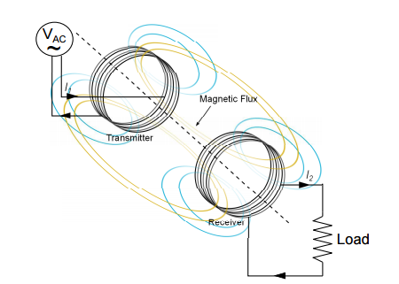
Figure 2: Principle of operation of inductive wireless power transfer.

  - 3.1 Resonant inductive coupling
Everything in the universe is simply energy vibrating at a certain frequency. Things that vibrate at a similar frequencies are attracted to one another, like a magnet they create a match. This is the science behind law of attraction or what is referred to as resonance.

Intuitively, two resonant coils of the same resonant frequency tend to exchange energy very efficiently, while dissipating relatively little energy around. In systems of coupled resonances, there is often a strong coupling regime. If one can operate in that regime, the efficiency improves dramatically.

If resonant coupling is used, each coil is capacitively loaded so as to form a tuned LC-circuit as shown in Fig. 3. If the primary and secondary coils resonate at a given frequency, the power transmitted between them over a range of a few times the primary coil diameter increases significantly with a reasonable efficiency. Tuning the LC circuits to keep operating them at resonant frequency is the main important point of WPT.

Nikola Tesla first discovered resonant coupling during his experiments in wireless power transfer, but the possibilities of using resonant coupling to increase transmission range has only recently been explored. In 2007 a team at MIT used two coupled tuned circuits each made of a 25 cm self-resonant coil of wire at 10 MHz to achieve the transmission of 60 W of power over a distance of 2 meters (8 times the coil diameter) at around 40% efficiency [3].

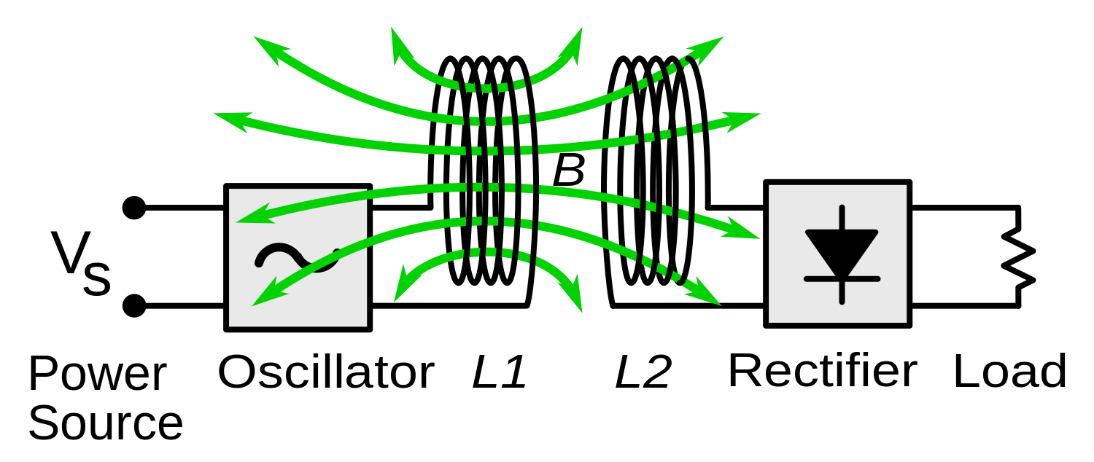
Figure 3: Generic block diagram of an inductive wireless power system (2-coil system) [3].

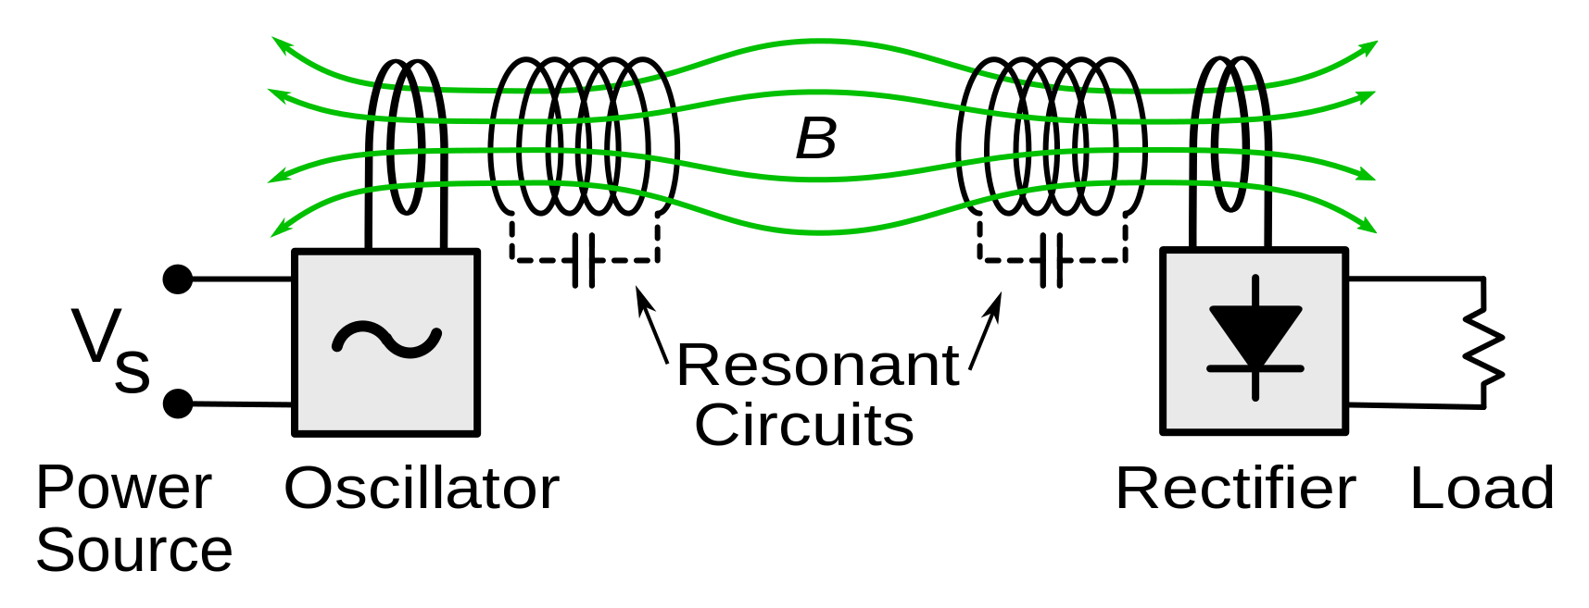
Figure 4: Diagram of the resonant inductive wireless power system demonstrated by MIT team in 2007 (4-coil system). The resonant circuits were coils of copper wire which resonated with their internal capacitance (dotted capacitors) at 10 MHz. Power was coupled into the transmitter resonator, and out of the receiver resonator into the rectifier, by small coils which also served for impedance matching [3].

4 Resonant WPT system for a drone

The efficient design of resonant circuits for wireless power transfer is far from trivial. Therefore a general block diagram is depicted in Fig. 5. The system comprises:

- Transmitter circuit that consists of:
  - Transmitter coil that is mounted on the drone.
  - Transmitter printed circuit board (T-PCB) that consists of:
    - DC/AC inverter which converts the DC current of the battery to an AC current. The AC current feeds the transmitter coil to generate an alternating magnetic field.
    - A capacitor that is added to make the transmitter coil resonate at the desirable frequency.
    - A microcontroller to derive the MOSFETs of the inverter. The microcontroller can also be used to program a control algorithm for increasing the efficiency of the system.
- Receiver circuit that consists of:
  - Receiver coil.
  - Receiver printed circuit board (T-PCB) that consists of:
    - AC/DC converter (rectifier)
    - Voltage regulator.

The system shown in Fig. 5 is 2-coil resonant system, a 4-coil resonant system can also be used if it gives higher efficiency than the 2-coil system. In [5] a 4-coil resonant wireless power transfer system has been designed and built to recharge wireless sensors.

Figure 5: Drone with resonant WPT

4 Material/data provided to the student

- Enable signal from zybo board. The transmitter circuit should be designed to contain an enable input to activate/deactivate the WPT.
- The load will be provided. The transmitter circuit should be designed to ensure a maximum voltage of 10 V. The load is a LED wall. The WPT system should be efficient enough to supply sufficient power to the load to turn on all of the LEDs.


Figure 6: The LED wall
- Datasheets of the main components will be also provided on Toledo. More precisely, datasheets concerning:
- Copper wire for the transmitter and receiver coils.
- IRFSL7440PbF MOSFET for the design of the DC/AC inverter.
- STM32 microcontroller for deriving the inverter and programming the different control algorithms.
- BYQ28EF dual common cathode ultrafast rectifier for the design of the rectifier.
- L78xx voltage regulator.

- Documentation.
- The references cited in this tutorial provide a sufficient theoretical knowledge needed to design the resonant WPT system. The references are on Toledo.

5 Tasks to perform

All tasks are to be performed by 2 students.

5.1 System Analysis and concepts

Before starting a design of resonant WPT, one should be familiar with the following concepts and issues:
- $S_{21}$ transmission coefficient as function of the distance between the coils and the frequency, S21 (d,$ω$).
- Quality factor, coupling factor, critical coupled threshold and over coupling.
- The issue of frequency splitting and the solution to solve this problem.
- Sensitivity of the WPT to the load impedance in terms of efficiency.
- Comparison between non-resonant inductive coupling circuit and resonant coupling based circuit in terms of efficiency.
- Series resonance vs. parallel resonance.
- Comparison between 2-coil resonant system and 4-coil resonant system.
- Maximizing efficiency with adaptive circuits like: (a) adaptive circuit of frequency control and tracking, (b) impedance matching control.

The designer should decide whether to build the system based on 2-coil system or 4-coil system and if it is 2-coil system, should it be series resonance or parallel resonance at the transmitter and receiver. The designer should also think of a methodology to increase the efficiency of the WPT system due to the decrease of the coupling between the resonators as the distance increases and due to the variation of load impedance.

Task: go to Toledo and download the references inside the file “system analysis”. Read the references and understand to the above mentioned issues and problems [6-11].

5.2 System Design

The general block diagram of the resonant WPT system that has to be designed and built is depicted in Fig. 7.

Figure 7: Block diagram of the resonant wireless power transfer system

Subtasks:

- Decide the type of the resonant WPT system to be designed, 2-coil system or 4-coil system.

- Calculate number of turns in the coils.
  - The datasheet of the copper wire is on Toledo.
  - The radius of the coils equals the radius of the drone. Of course, another (better) suggestion may be chosen (with e.g. s higher efficiency)

Figure 8: Suggestion of the coil’s radius
- Size the capacitors to make the coils resonate at a desirable frequency.
  - Resonant coils should resonate at the same frequency, with high enough quality factor. The selected operating frequency affects the size and the weight of the system as well as the efficiency.
  - The resonant frequency shouldn’t exceed the maximum switching frequency of the inverter.

- Design an H bridge inverter to convert the DC voltage/current to AC.
  - The datasheet of the MOSFET that will be used in the design is on Toledo.
  - The inverter should include an enable input to activate/deactivate the transfer of the power.

- Design a full wave bridge rectifier to convert the induced AC voltage/ current (at the receiver side) to DC.

- Regulate the final output voltage to 10V DC.

- Derive a formula for the $S_{21}$ transmission coefficient of the designed WPT system.
  - $S_{21}$ is an important parameter in WPT as it determines the power transfer efficiency ($η={\left|S_{21}\right|}^{2}$).
  - Draw $S_{21}$ as function of the distance (between the transmitter resonant coils and receiver resonant coils) and frequency (3D figure).
  - Does the resonant frequency change with changing the distance?
  - Notice the frequency splitting.
  - What is the critical coupled threshold?

- Design an adaptive circuit/algorithm to maximize the efficiency of the WPT system.
  - The power transfer efficiency significantly decreases with distance variations between the transmitter and the receiver coils. To overcome this issue, adaptive circuits/algorithms are needed to maintain the optimal resonant condition and realize maximum WPT efficiency as well.
  - An adaptive circuits/algorithms could be based on frequency tracking or based on impedance matching control.
  - Examples on different adaptive control systems can be found in the “system analysis” folder on Toledo.

5.3 System validation

- Validate the design of the WPT system using MATLAB/Simulink.

- A tutorial session will be given to the students on how to use MATLAB/Simulink to model WPT systems.

5.4 Prototype and PCB

- Construct a prototype (of the transmitter circuit and receiver circuit) on a breadboard (including the construction of the coils).

- Verify experimentally that the design actually works.

- Transfer the final design to a PCB to be integrated with the drone.
  - Use Altium software to design the PCB.
  - Tutorial - Getting Started with PCB Design can be found in [12].
  - Very extensive PCB design manual is on Toledo [13]

5.6 Integration with the drone

- Install the transmitter circuit and the transmitter coil/coils on the drone.
- Connect the battery to the transmitter circuit.
- Connect the WPT enable output of the zypo to the WPT enable input of transmitter circuit.
- Connect the receiver circuit to the load.

- Mission:

Fly the drone towards the load. When the drone is at height of 20 cm from the receiver coil, enable the WPT using the remote control so that the system can start transferring power from this height to the load.

Figure 9: WPT mission

6 Milestones
- Submitting a report that discusses that the concepts and issues of WPT presented in section 5.1. T1 (mid October)
- Demo for WPT. T2 (mid of December)
  - Showing the MATLAB/Simulink model.
  - Experiment on breadboard (without the implementation of the adaptive circuit/algorithm but the general overview of the design should be presented).
- PCB design finished. T2 (mid December)
- Demo with PCB assembly working. T3 (mid of March)
  - Including the adaptive circuit/algorithm for maximizing the efficiency.
  - The system should successfully transfer sufficient power from the transmitter coil (that will be located manually 20 cm far from the receiver side) to turn on the whole LED wall.
- WPT system integrated on the drone and working. Final test. T4 (mid of May)
  - Demo to show the WPT mission as in figure 9.

7 References

[1] | "Unmanned aerial vehicle,"  https://en.wikipedia.org/wiki/Unmanned_aerial_vehicle  retrieved on August 1, 2017.
[2] | "20 great UAV applications areas for drones,"  http://air-vid.com/wp/20-great-uav-applications-areas-drones/  retrieved on August 1, 2017.
[3] | S. Y. R. Hui, "Magnetic Resonance for Wireless Power Transfer [A Look Back]," in IEEE Power Electronics Magazine, vol. 3, no. 1, pp. 14-31, March 2016.
[4] | "Wireless power transfer,"  https://en.wikipedia.org/wiki/Wireless_power_transfer  retrieved on August 1, 2017.
[5] | Griffin, Brent, and Carrick Detweiler. "Resonant wireless power transfer to ground sensors from a UAV." Robotics and Automation (ICRA), 2012 IEEE International Conference on. IEEE, 2012.
[6] | Huang, Runhong, and Bo Zhang. "Frequency, impedance characteristics and HF converters of two-coil and four-coil wireless power transfer." IEEE Journal of Emerging and selected topics in Power Electronics 3.1 (2015): 177-183
[7] | Cannon, Benjamin L., et al. "Magnetic resonant coupling as a potential means for wireless power transfer to multiple small receivers." IEEE transactions on power electronics 24.7 (2009): 1819-1825.
[8] | Sample, Alanson P., et al. "Enabling seamless wireless power delivery in dynamic environments." Proceedings of the IEEE 101.6 (2013): 1343-1358.
[9] | Hoang, Huy, and Franklin Bien. "Maximizing efficiency of electromagnetic resonance wireless power transmission systems with adaptive circuits." Wireless Power Transfer-Principles and Engineering Explorations. InTech, 2012.
[10] | Jay, Rajiv, and Samuel Palermo. "Resonant coupling analysis for a two-coil wireless power transfer system." Circuits and Systems Conference (DCAS), 2014 IEEE Dallas. IEEE, 2014.
[11] | Barman, Surajit Das, et al. "Two-side Impedance Matching for Maximum Wireless Power Transmission." IETE Journal of Research 62.4 (2016): 532-539.
[12] | "Tutorial - Getting Started with PCB Design ,"  https://techdocs.altium.com/display/ADOH/Tutorial+-+Getting+Started+with+PCB+Design  retrieved on August 1, 2017.
[13] | Very extensive PCB design manual:  http://server.ibfriedrich.com/wiki/ibfwikien/images/d/da/PCB_Layout_Tutorial_e.pdf

